**TUGAS PENDAHULUAN**

**PRAKTIKUM 9**

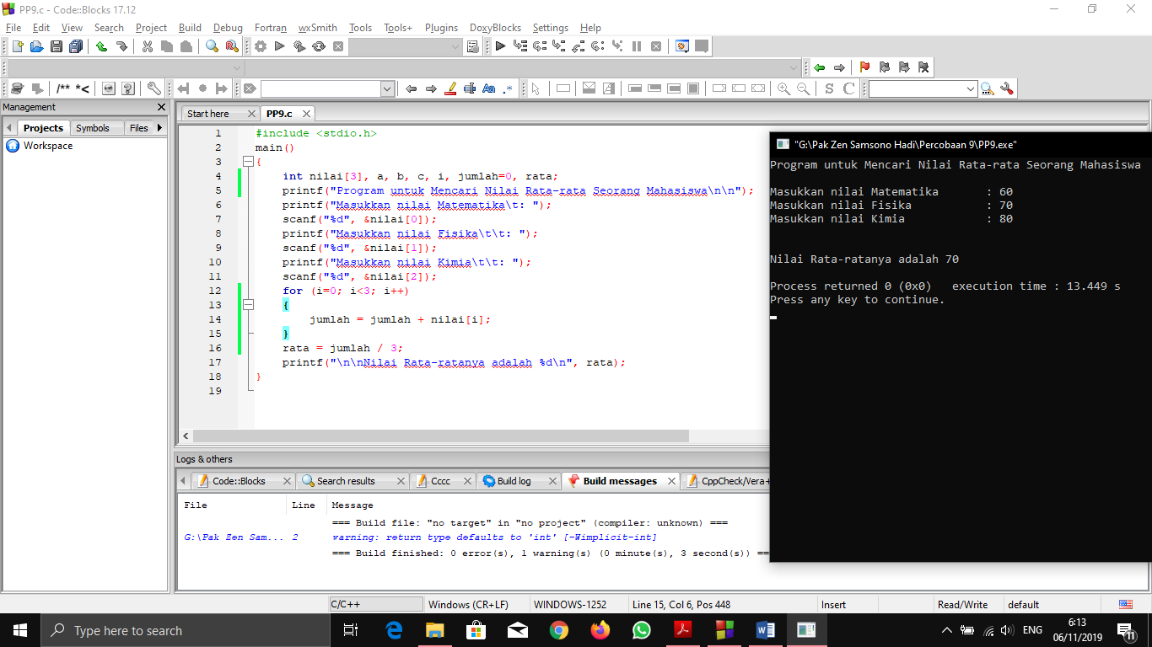

#include <stdio.h>

main()

{

int nilai[3], a, b, c, i, jumlah=0, rata;

printf("Program untuk Mencari Nilai Rata-rata Seorang Mahasiswa\n\n");

printf("Masukkan nilai Matematika\t: ");

scanf("%d", &nilai[0]);

printf("Masukkan nilai Fisika\t\t: ");

scanf("%d", &nilai[1]);

printf("Masukkan nilai Kimia\t\t: ");

scanf("%d", &nilai[2]);

for (i=0; i<3; i++)

{

jumlah = jumlah + nilai[i];

}

rata = jumlah / 3;

printf("\n\nNilai Rata-ratanya adalah %d\n", rata);

}

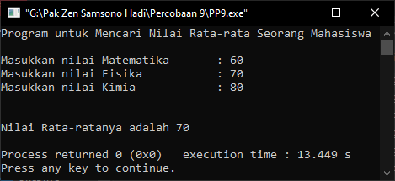

**LAPORAN PERCOBAAN**

**PRAKTIKUM 9**

**PERCOBAAN 1**

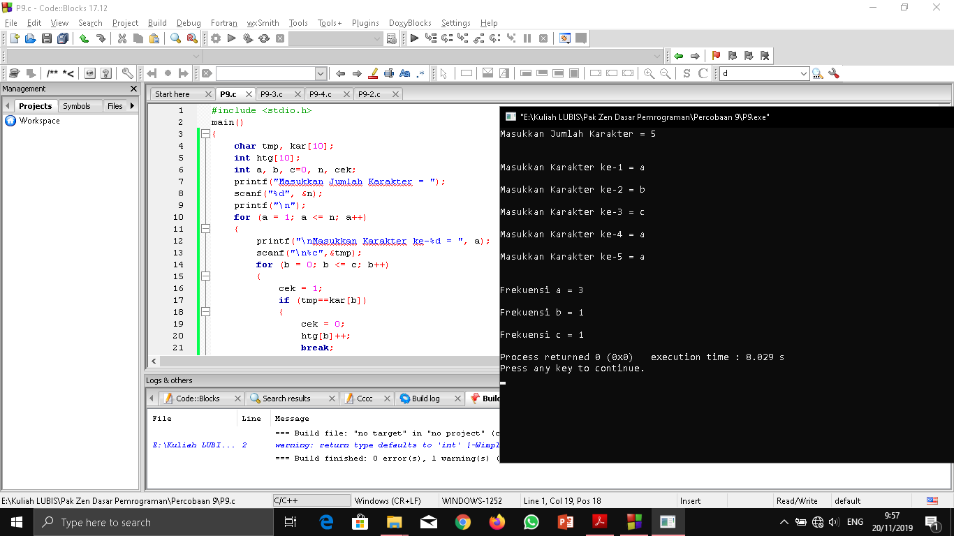

#include <stdio.h>

main()

{

char tmp, kar[10];

int htg[10];

int a, b, c=0, n, cek;

printf("Masukkan Jumlah Karakter = ");

scanf("%d", &n);

printf("\n");

for (a = 1; a <= n; a++)

{

printf("\nMasukkan Karakter ke-%d = ", a);

scanf("\n%c",&tmp);

for (b = 0; b <= c; b++)

{

cek = 1;

if (tmp==kar[b])

{

cek = 0;

htg[b]++;

break;

}

}

if (cek==1)

{

kar[c] = tmp;

htg[c] = 1;

c++;

}

}

printf("\n");

for (a = 0; a < c; a++)

{

printf("\nFrekuensi %c = %d\n", kar[a], htg[a]);

}

}

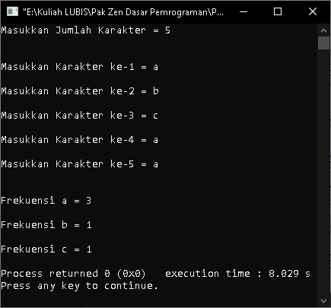

**PERCOBAAN 2**

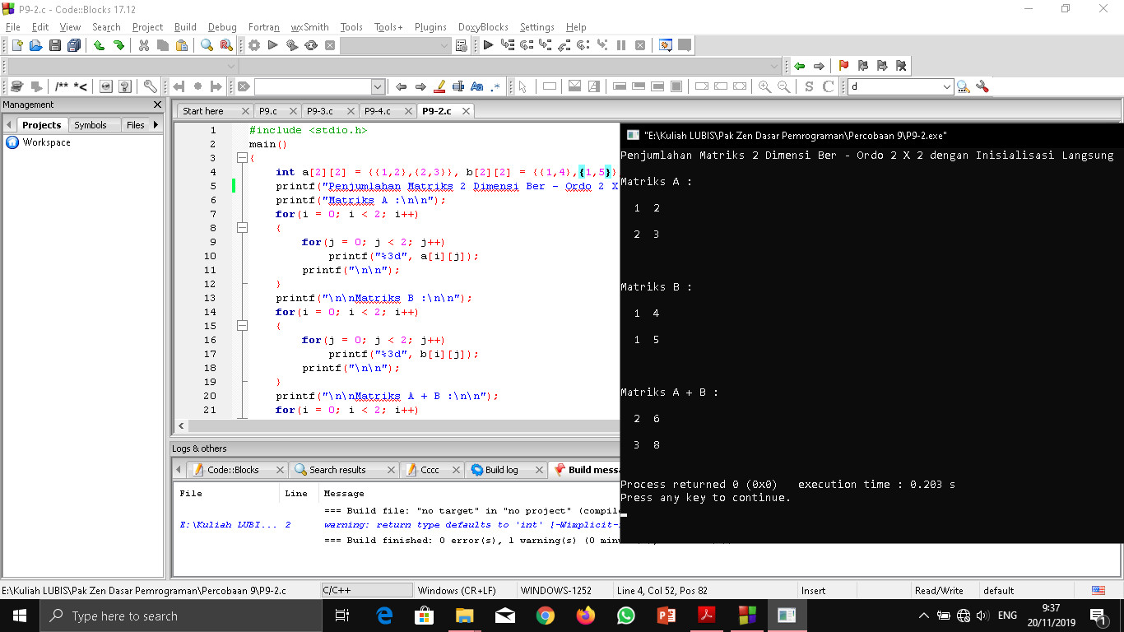

#include <stdio.h>

main()

{

int a[2][2] = {{1,2},{2,3}}, b[2][2] = {{1,4},{1,5}}, i, j;

printf("Penjumlahan Matriks 2 Dimensi Ber - Ordo 2 X 2 dengan Inisialisasi Langsung\n\n");

printf("Matriks A :\n\n");

for(i = 0; i < 2; i++)

{

for(j = 0; j < 2; j++)

printf("%3d", a[i][j]);

printf("\n\n");

}

printf("\n\nMatriks B :\n\n");

for(i = 0; i < 2; i++)

{

for(j = 0; j < 2; j++)

printf("%3d", b[i][j]);

printf("\n\n");

}

printf("\n\nMatriks A + B :\n\n");

for(i = 0; i < 2; i++)

{

for(j = 0; j < 2; j++)

{

a[i][j] = a[i][j] + b[i][j];

printf("%3d", a[i][j]);

}

printf("\n\n");

}

}

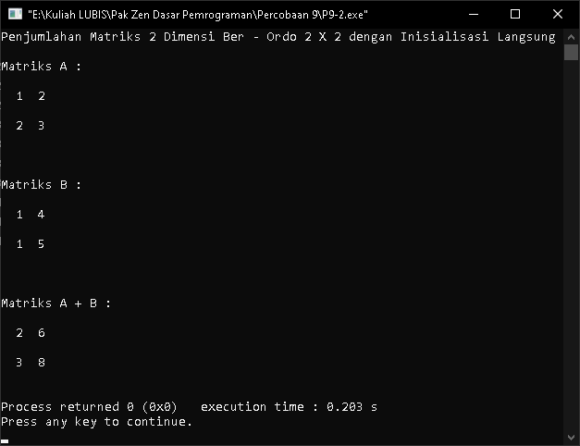

**PERCOBAAN 3**

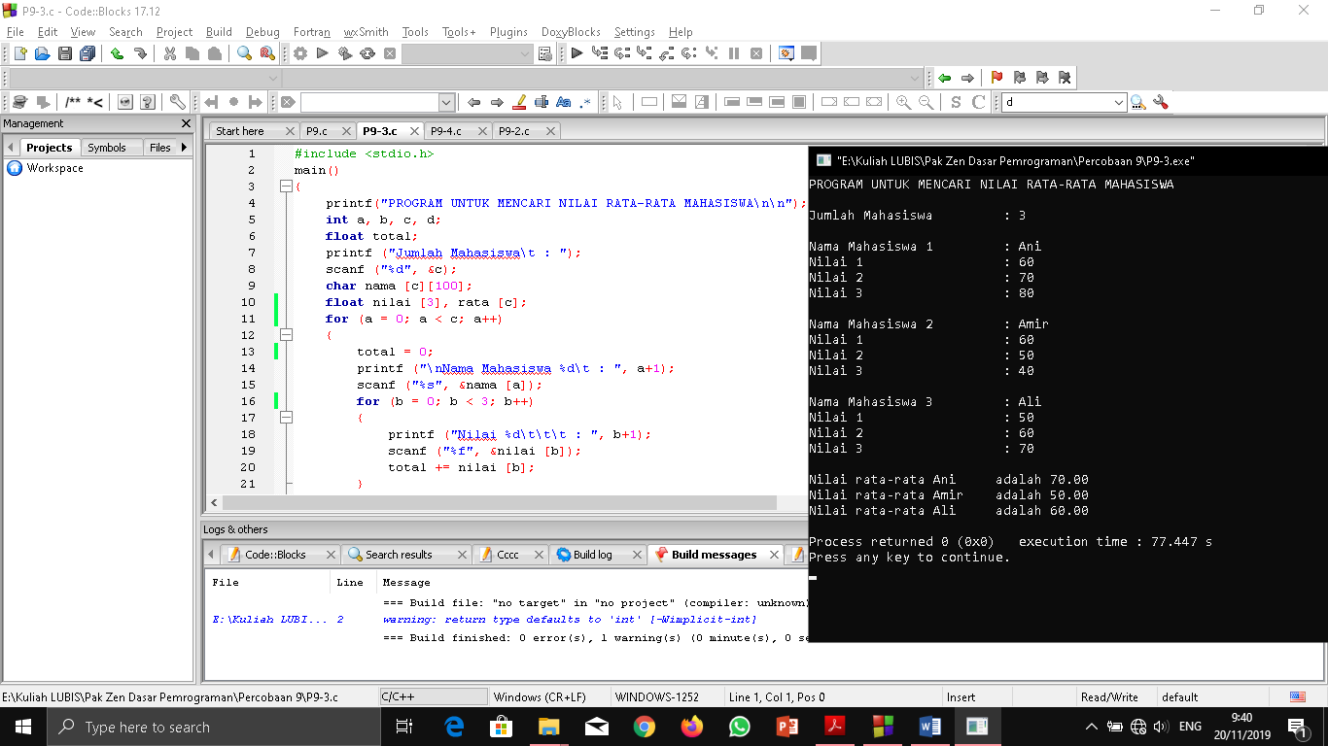

#include <stdio.h>

main()

{

printf("PROGRAM UNTUK MENCARI NILAI RATA-RATA MAHASISWA\n\n");

int a, b, c, d;

float total;

printf ("Jumlah Mahasiswa\t : ");

scanf ("%d", &c);

char nama [c][100];

float nilai [3], rata [c];

for (a = 0; a < c; a++)

{

total = 0;

printf ("\nNama Mahasiswa %d\t : ", a+1);

scanf ("%s", &nama [a]);

for (b = 0; b < 3; b++)

{

printf ("Nilai %d\t\t\t : ", b+1);

scanf ("%f", &nilai [b]);

total += nilai [b];

}

rata [a] = total/c;

}

printf ("\n");

for (a = 0; a < c; a++)

{

printf ("Nilai rata-rata %s\tadalah %.2f\n", nama [a], rata [a]);

}

}

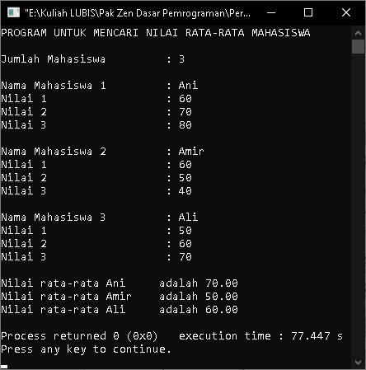

**PERCOBAAN 4**

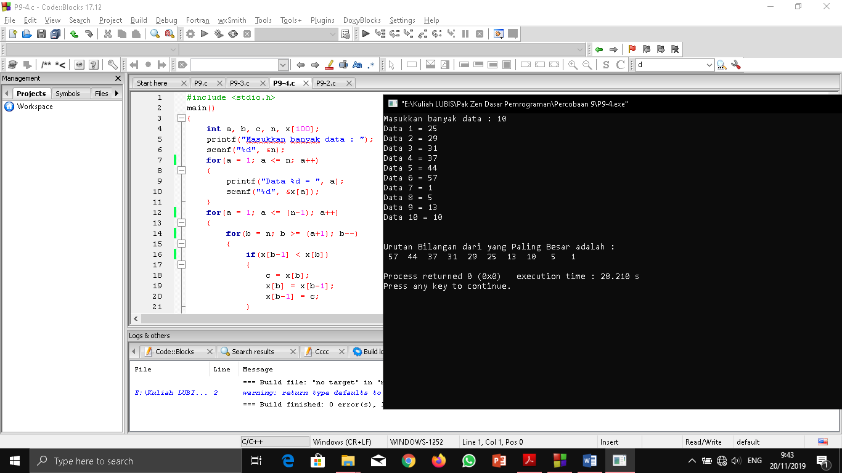

#include <stdio.h>

main()

{

int a, b, c, n, x[100];

printf("Masukkan banyak data : ");

scanf("%d", &n);

for(a = 1; a <= n; a++)

{

printf("Data %d = ", a);

scanf("%d", &x[a]);

}

for(a = 1; a <= (n-1); a++)

{

for(b = n; b >= (a+1); b--)

{

if(x[b-1] < x[b])

{

c = x[b];

x[b] = x[b-1];

x[b-1] = c;

}

}

}

printf("\n\nUrutan Bilangan dari yang Paling Besar adalah :\n");

for(a = 1; a <= n; a++)

{

printf("%3d ", x[a]);

}

printf("\n");

}

